**RTP Packet Format:**

Figure1 shows the format of the RTP packet header. The format is very simple and general enough to cover all real-time applications. An application that needs more information adds it to the beginning of its payload. A description of each field follows.

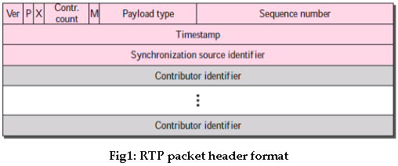

* **Ver:** This 2-bit field defines the version number. The current version is 2.
* **P:** This 1-bit field, if set to 1, indicates the presence of padding at the end of the packet. In this case, the value of the last byte in the padding defines the length of the padding. Padding is the norm if a packet is encrypted. There is no padding if the value of the P field is 0.
* **X:** This 1-bit field, if set to 1, indicates an extra extension header between the basic header and the data. There is no extra extension header if the value of this field is 0.
* **Contributor count:** This 4-bit field indicates the number of contributors. Note that we can have a maximum of 15 contributors because a 4-bit field only allows a number between 0 and 15.
* **M:** This 1-bit field is a marker used by the application to indicate, for example, the end of its data.
* **Payload type:** This 7-bit field indicates the type of the payload. Several payload types have been defined so far. Some common applications in Table2.

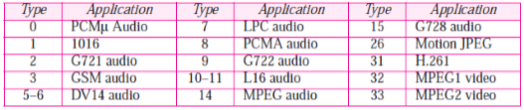

**Table2 :Payload Types**

* **Sequence number:** This field is 16 bits in length. It is used to number the RTP packets. The sequence number of the first packet is chosen randomly; it is incremented by 1 for each subsequent packet. The sequence number is used by the receiver to detect lost or out of order packets.
* **Timestamp:** This is a 32-bit field that indicates the time relationship between packets. The timestamp for the first packet is a random number. For each succeeding packet, the value is the sum of the preceding timestamp plus the time the first byte is produced (sampled). The value of the clock tick depends on the application. For example, audio applications normally generate chunks of 160 bytes; the clock tick for this application is 160. The timestamp for this application increases 160 for each RTP packet.
* **Synchronization source identifier:** If there is only one source, this 32-bit field defines the source. However, if there are several sources, the mixer is the synchronization source and the other sources are contributors. The value of the source identifier is a random number chosen by the source. The protocol provides a strategy in case of conflict (two sources start with the same sequence number).
* **Contributor identifier:** Each of these 32-bit identifiers (a maximum of 15) defines a source. When there is more than one source in a session, the mixer is the synchronization source and the remaining sources are the contributors.